Null Hypothesis: Employing more people results in higher liabilities.

Alternative Hypothesis: Employing more people does not result in higher liabilities.

Here, we are confused in which to look at as the **Pearson correlation** in option 4: “Cor:Employment rate & Liabilities”, or to look at the **p-value** in option 1, ***to prove our alternative hypothesis to be true***?

It shows that its correlation of employment rate and liabilities is -0.039***. Does this shows that it indicates the presence of a weak downhill (negative) linear relationship?*** And also, ***the negative sign indicates that when Employment rate increases, its total liabilities of a company value decreases?***

If so, we want to further support our answer by using regression in R:

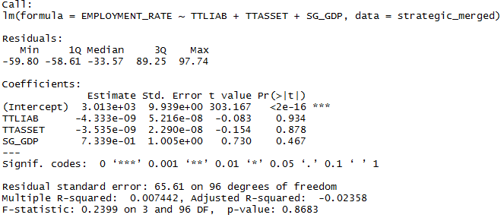

The output shows that F=0.2399 (p=0.8683), indicating that we should fail to reject the null hypothesis that the variables total Liabilities, total Assets and GDP have effect on employment rate. The result also shows that the p-value of the variables is not statistically significant. In other words, we are reasonably sure that our observed data can be explained by chance alone.

Is our assumption correct from the paragraph above? If so, does it mean that our null hypothesis is true? Which does not supports our assumption as a whole, means that our alternative hypothesis is not true.

1. What model Variables stands for:

|  |  |
| --- | --- |
| **Field** | **Value** |
| **Author** | Elixir Technology |
| **Maintainer** | Elixir Technology |
| **1.0 Version** | 1.0 |
| **1.1 Free/Paid** | Paid |
| **1.2 SSIC Classification 1** | Information and Communications |
| **1.3 SSIC Classification 1.1** | Information Service Activities |
| **1.4 SSIC Classification 2** | Information and Communications |
| **1.5 SSIC Classification 2.1** | Computer Programming, Consultancy and Related Activities |
| **1.6 Quality Indicator 1: Total No. of Records** | 1753 |
| **1.7 Quality Indicator 2: No. of completely filled records/Total no. of records** | 1 |
| **1.8 Quality Indicator 3: No. of empty records/Total no. of records** | 0.0 |
| **1.9 Quality Indicator 4: No. of fields per record** | 28 |
| **2.0 Quality Indicator 5: Dataset last update** | 11/12/2014 12:58:00 PM |
| **2.1 Quality Indicators last generated** | 11/12/2014 12:58:00 PM |
| **Data Field 01: COYNAME** | Company Name |
| **Data Field 02: REGNO** | UEN |
| **Data Field 03: ACCTYPEDESEC** | Type of Account Filed |
| **Data Field 04: COYDESC** | Type of Company |
| **Data Field 05: FYEAR** | Year of Financial Filing. Data for the past 3 years, 2009 to 2011 |
| **Data Field 06: REVENUE_AMT** | Revenue f.k.a [Sales Turnover And Other Operating Revenues] |
| **Data Field 07: PBFTAX** | Profit before Tax from Continuing Operations f.k.a [Profit before Tax] |
| **Data Field 08: LBFTAX** | Loss before Tax from Continuing Operations f.k.a [Loss before Tax] |
| **Data Field 09: PAFTAX** | Profit after Tax from Continuing Operations f.k.a [Profit After Tax] |
| **Data Field 10: LAFTAX** | Loss after Tax from Continuing Operations f.k.a [Loss After Tax] |
| **Data Field 11: TTASSET** | Total Assets |
| **Data Field 12: TTCRASSET** | Total Current Assets |
| **Data Field 13: TTNCRASSET** | Total Non-Current Assets |
| **Data Field 14: TTLIAB** | Total Liabilities |
| **Data Field 15: TTCRLIAB** | Total Current Liabilities |
| **Data Field 16: TTNCRLIAB** | Total Non-Current Liabilities |
| **Data Field 17: TTEQUITY** | Total Equity f.k.a. [Shareholder's Funds] |
| **Data Field 18: PUCAP** | Paid-Up Capital |
| **Data Field 19: SHARECAP** | Share Capital |
| **Data Field 20: OTHERRESERVESTT** | Other Reserves, Total f.k.a. [Reserves] |
| **Data Field 21: RETAINEARN** | Retained Earnings/(Accumulated Loss) |
| **Data Field 22: AR_NETPROFITSALES** | Rate of Net Profit on Sales (%). Derived value from the formula: 100 * Net Profit After Tax / Turnover (Sales) |
| **Data Field 23: AR_RETINVESTMENT** | Return of Investment (%). Derived value from the formula: 100 * Net Profit After Tax / Total Assets |
| **Data Field 24: AR_RETSHAREFUNDS** | Return of Shareholder's Funds (%). Derived value from the formula: 100 * Net Profit After Tax / Shareholder's Funds |
| **Data Field 25: AR_TASSETSTO** | Total Assets Turnover (%). Derived value from the formula: Turnover (Sales) / Total Assets |
| **Data Field 26: AR_CURRWCAP** | Current/Working Capital Ratio (%). Derived value from the formula: Current Assets / Current Liabilities |
| **Data Field 27: PROPRATIO** | Proprietary Ratio(%). Derived value from the formula: 100 * Shareholder's Funds / Total Assets |
| **Data Field 28: AR_TOTALDEBT** | Total Debt to Equity Ratio (%). Derived value from the formula: 100 * Total Liabilities / (Total Liabilities + Shareholder's Funds) |
| **Data Field 29: EMPLOYMENT_RATE** | Number of employed persons in Singapore. |
| **Data Field 30: SG_GDP** | Singapore’s Gross Domestic Product-Real Growth Rate |

Definition of variables:

* Definition of GDP - real growth rate: This entry gives GDP growth on an annual basis adjusted for inflation and expressed as a percent.
* Definition of Employment rate: Employed persons are individuals with a minimum required age who work during a certain time for a business.
* Definition of Total Assets: Total Assets are the sum of all current and non-current assets that a company owns. Current assets is in the form of cash and non-current assets is examples lands, machineries. In short, everything the company owned and have.
* Definition of Total Liabilities: Company’s legal debts or obligation that arise during the course of business operations (Eg. Loans, accounts payable, mortages)

1. Correlation plots of all pair variables:

As we only used, EMPLOYMENT RATE, TTLIAB, TTASSET & SG_GDP from the dataset:

Here’s the correlation of all pair-wise combinations of variables:

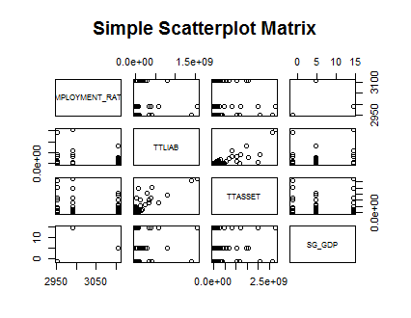

|  |  |
| --- | --- |
| **Company** | **Annual Report** |
| Bousted | <http://www.boustead.sg/investor_centre/financial_highlights.asp> |
| China Taisan | <http://www.china-taisan.com/attachment/201505131924461768493043_en.pdf> |
| LionaPac | <http://www.lionapac.com/images/Annual_Report_2010.pdf> |
| MapleTree | <http://www.mapletreelogisticstrust.com/en/Investor-Relations/Publications-Presentations/Annual-Reports.aspx> |
|  |  |
|  |  |
|  |  |